Name: Dexter D. Mangalindan

Year | Section:BSIT-3rd year

Date: May 15, 2024 – **Deadline will be today at 6:25 PM only.**

This must be the name of your word document – LASTNAME_INITIAL(APPDEV-MID) **TUNGUL_RD(APPDEV-MID)**

**(MIDTERM EXAM) APPLICATION DEVELOPMENT**

1. Create a Copy and Paste website content that can cater the audience need (i.e., copying the machine/devices text or files):

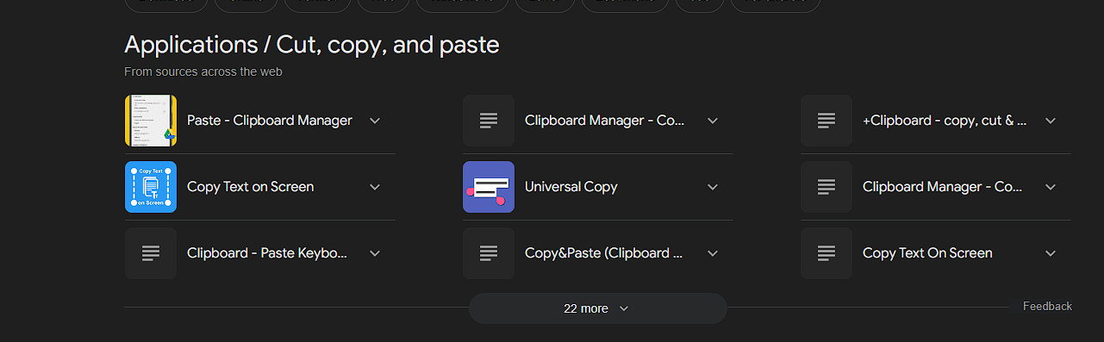

1. Upload your file via GitHub and named it as: username.github.io/appdev-midterm

[rdtungul.github.io/appdev-midterm/](https://rdtungul.github.io/appdev-midterm/)

https://deiijiii.github.io/appdev-midterm/

1. Create your own sentence/wordings and replace all the Lorem ipsum text into your generated sentences (Note: images and icons are fixed). Add a metadata inside the head section. Please make sure that your design is 1:1, unique, and up to date:

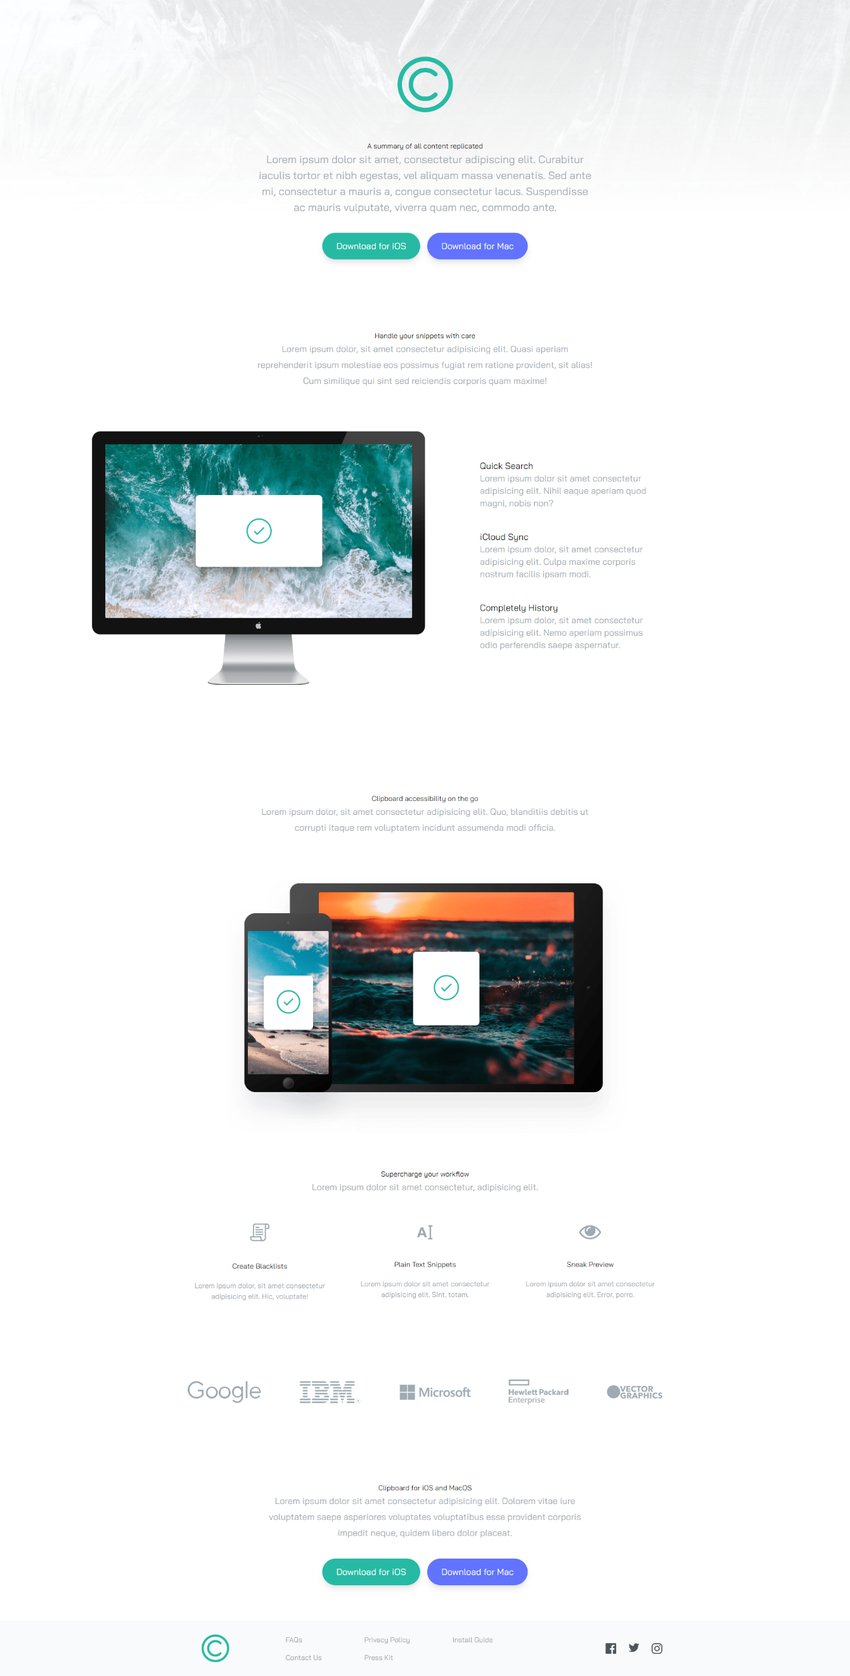

1. Make the site’s speed up to 98% on all aspects using Google PageSpeed Insights. (Note: Web layout only)

1. Network speed must be faster than the original speed. (Note: speed must be less than 2.5 seconds)

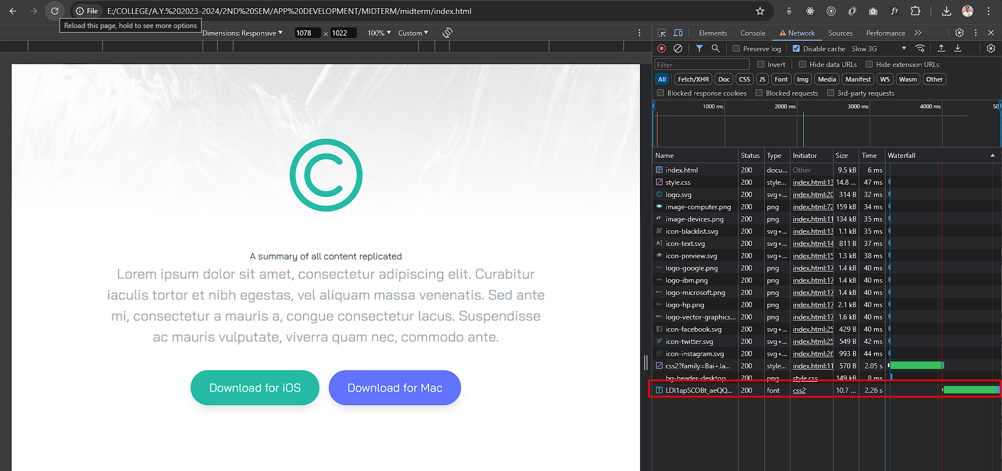

Save your screenshots here:

https://pagespeed.web.dev/analysis/https-deiijiii-github-io-appdev-midterm/kohy5qjt6w?form_factor=desktop

Save your code here:

<!DOCTYPE html>

<html lang="en">

<head>

<!-- Meta here -->

<meta charset="UTF-8">

<meta name="viewport" content="width=device-width, initial-scale=1.0 Author: Dexter D. Mangalindan , Website: Content Replicated,">

<meta name="description" content="Replication creates multiple copies of the same data for various purposes. A summary of all replicated content essentially compresses the key points of these copies into a single, more manageable representation."/>

<!-- google fonts -->

<link rel="preconnect" href="https://fonts.googleapis.com" />

<link rel="preconnect" href="https://fonts.gstatic.com" crossorigin />

<link

href="https://fonts.googleapis.com/css2?family=Bai+Jamjuree:wght@400;600&display=swap"

rel="stylesheet"

/>

<link rel="stylesheet" href="css/style.css" />

<title>Copy Clipboard (Midterm Exam)</title>

</head>

<body>

<!-- Hero Section -->

<section id="hero">

<div class="pt-16 mb-40 section-container">

<img src="./images/logo.min.svg" alt="" class="mx-auto my-16" />

<h1><b>A summary of all content replicated</b></h1>

<p class="mb-10 text-1xl section-content">

In WebCenter Sites, you can replicate sites with Site Launcher. You can replicate a Content Management (CM)

site and share or copy its components to the new site. You can also modify and deploy the new site.

</p>

<!-- Button Container -->

<div class="button-container">

<a

href="#" target="_blank" role="button" aria-label="Just a button" style="color:black"

class="p-4 px-9 duration-300 rounded-full shadow-lg bg-strongCyan hover:opacity-100"

>

<b>Download for iOS</b>

</a>

<a

href="#" target="_blank" role="button" aria-label="Just a button" style="color: black;"

class="p-4 px-9 duration-300 rounded-full shadow-lg bg-lightBlue hover:opacity-100"

>

<b>Download for Mac</b>

</a>

</div>

</div>

</section>

<!-- Snippets Section -->

<section id="snippets">

<div class="my-20 section-container">

<h2><b>Handle your snippets with care</b></h2>

<p class="mb-24 text-1xl section-content">

This snippet reads the current company as well as the #1 listed skill from someone's LinkedIn profile page. It is using the

LinkedIn command pack to get their first name, but that's possible through the site selector as well.

</p>

</div>

</section>

<!-- Features Section -->

<section id="features">

<div class="my-20 section-container">

<div class="relative flex flex-col md:flex-row md:space-x-32">

<!-- Image -->

<div class="md:w-1/2">

<img

src="./images/image-computer.min.png"

alt=""

class="md:absolute top-0 right-[50%]"

/>

</div>

<!-- Items Container -->

<div

class="flex flex-col mt-16 mb-24 space-y-12 text-xl md:w-1/2 md:mb-60 md:text-left md:pl-16"

>

<!-- Item 1 -->

<div>

<p>Quick Search</p>

<p class="max-w-md text-grayishBlue">

Quick Search is an easy to use and incredibly powerful social media search engine that helps you boost your brand and communication impact.

</p>

</div>

<!-- Item 2 -->

<div>

<p>iCloud Sync</p>

<p class="max-w-md text-grayishBlue">

Log in to iCloud to access your photos, mail, notes, documents and more.

Sign in with your Apple ID or create a new account to start using Apple services.

</p>

</div>

<!-- Item 3 -->

<div>

<p>Completely History</p>

<p class="max-w-md text-grayishBlue">

The complete History websites ranking list: Click here for free access to the

top History websites in the world, ranked by traffic and engagement.

</p>

</div>

</div>

</div>

</div>

</section>

<!-- Access Anywhere Section -->

<section id="access">

<div class="my-20 section-container">

<h3><b>Clipboard accessibility on the go</b></h3>

<p class="mb-24 text-1xl section-content">

I'm using Microsoft Windows XP. ... clipboard, you should not allow it.

It could be something sneaky, possibly gathering passwords or credit card information".

</p>

<img src="./images/image-devices.min.png" alt="" class="mx-auto" />

</div>

</section>

<!-- Supercharge Section -->

<section id="supercharge">

<div class="my-20 section-container">

<h4><b>Supercharge your workflow</b></h4>

<p class="mb-16 text-1xl section-content">

ChatGPT: Imagine having a brainstorming partner available 24/7. ChatGPT is your go-to AI for writing assistance, coding help, and learning new concepts.

It’s like having a personal research assistant who never sleeps.

</p>

<!-- Items Container -->

<div

class="flex flex-col items-center justify-between space-y-16 md:flex-row md:space-y-0 md:space-x-12"

>

<!-- Item 1 -->

<div class="flex flex-col items-center space-y-5">

<img src="images/icon-blacklist.min.svg" alt="" class="mb-6" />

<p>Create Blacklists</p>

<p class="max-w-md text-grayishBlue">

Block distracting websites & social media with these app & website blockers,

so that you can focus, boost your productivity and block

</p>

</div>

<!-- Item 2 -->

<div class="flex flex-col items-center space-y-5">

<img src="images/icon-text.min.svg" alt="" class="mb-6" />

<p>Plain Text Snippets</p>

<p class="max-w-md text-grayishBlue">

Conquer messy inboxes and save precious time with our list of 10 top text snippet

tools.Boost productivity, eliminate repetitive typing

</p>

</div>

<!-- Item 3 -->

<div class="flex flex-col items-center space-y-5">

<img src="images/icon-preview.min.svg" alt="" class="mb-6" />

<p>Sneak Preview</p>

<p class="max-w-md text-grayishBlue">

It is a website to share my knowledge and interests in

the field of computer graphics. I wanted to build this site, to help

</p>

</div>

</div>

</div>

</section>

<!-- References Section -->

<section id="references">

<div

class="flex flex-col items-center justify-between max-w-6xl px-10 mx-auto space-y-16 my-44 md:flex-row md:space-y-0"

>

<img src="./images/logo-google.min.png" alt="" />

<img src="./images/logo-ibm.min.png" alt="" />

<img src="./images/logo-microsoft.min.png" alt="" />

<img src="./images/logo-hp.min.png" alt="" />

<img src="./images/logo-vector-graphics.min.png" alt="" />

</div>

</section>

<!-- Bottom CTA Section -->

<section id="bottom">

<div class="my-20 section-container">

<h5><b>Clipboard for iOS and MacOS</b></h5>

<p class="mb-10 text-1xl section-content">

These Are the Best Clipboard Managers for Your Mac · Use a clipboard manager built into a launcher app

</p>

<!-- Button Container -->

<div class="button-container">

<a

href="#" target="_blank" role="button" aria-label="Just a button" style="color: black;"

class="p-4 px-9 duration-200 rounded-full shadow-lg bg-strongCyan hover:opacity-80"

>

<b>Download for iOS</b>

</a>

<a

href="#" target="_blank" role="button" aria-label="Just a button" style="color: black;"

class="p-4 px-9 duration-200 rounded-full shadow-lg bg-lightBlue hover:opacity-80"

>

<b>Download for Mac</b>

</a>

</div>

</div>

</section>

<footer class="bg-gray-50">

<div class="section-container">

<div class="flex flex-col items-center justify-between md:flex-row">

<!-- Image -->

<img src="images/logo.min.svg" alt="" class="scale-50" />

<!-- Container for Menus & Social -->

<div

class="flex flex-col items-center justify-between flex-1 mb-10 space-y-6 md:flex-row md:mb-0 md:space-y-0 text-grayishBlue"

>

<!-- Menus -->

<div

class="flex flex-col space-y-4 md:flex-row md:ml-24 md:space-x-24 md:space-y-0"

>

<!-- Menu 1 -->

<div class="flex flex-col space-y-4 text-center md:text-left">

<div><a href="#" class="hover:text-strongCyan" style="color: black;"><b>FAQs</b></a></div>

<div>

<a href="#" class="hover:text-strongCyan" style="color: black;"><b>Contact Us</b></a>

</div>

</div>

<!-- Menu 2 -->

<div class="flex flex-col space-y-4 text-center md:text-left">

<div>

<a href="#" class="hover:text-strongCyan" style="color: black;"><b>Privacy Policy</b></a>

</div>

<div>

<a href="#" class="hover:text-strongCyan" style="color: black;"><b>Press Kit</b></a>

</div>

</div>

<!-- Menu 3 -->

<div class="flex flex-col space-y-4 text-center md:text-left">

<div>

<a href="#" class="hover:text-strongCyan" style="color: black;"><b>Install Guide</b></a>

</div>

</div>

</div>

<!-- Social Icons -->

<div class="flex justify-between w-32 py-1">

<a href="https://www.facebook.com/Dexxxtteerrr"target="_blank" role="button" aria-label="Facebook Account"

><img

src="images/icon-facebook.min.svg"

alt=""

class="duration-200 ficon"

/></a>

<a href="https://twitter.com/Dexxxxqt?t=HIpXXnDNLzyDSUXUtTTHAA&s=07" target="_blank" role="button" aria-label="Twitter/X account"

><img

src="images/icon-twitter.min.svg"

alt=""

class="duration-200 ficon"

/></a>

<a href="https://www.instagram.com/_dexx.m/" target="_blank" role="button" aria-label="Instagram Account"

><img

src="images/icon-instagram.min.svg"

alt=""

class="duration-200 ficon"

/></a>

</div>

</div>

</div>

</div>

</footer>

</body>

</html>

*** Warning: Duplicate design for the resume will be investigated and reviewed. ***

Goodluck and keep going! You can do it!

___________________

**Roseph Darl Tungul**

Instructor